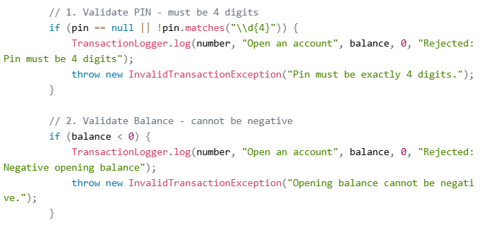

We did not know how to make our pin to allow only 4 digits so we asked Meta AI to help us, and we took the code as it is but changed the text inside the codes(“”).

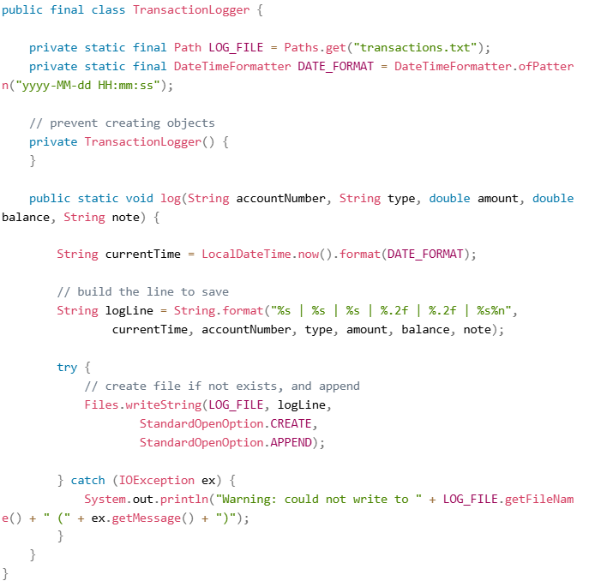
We did not know anything about making the TransactionLogger so we consulted Meta AI for assistance and changed thing where necessary.

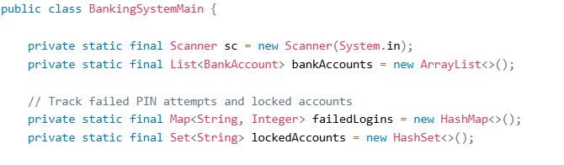

Our program was still running perfectly, but we were able to guess a pin without limit and If we took out accounts, the program had no data to work with at all so we asked Meta AI for assistance and changed things where necessary.

NAMES | STUDENT ID
Bokhabane Ntsema | 901020604
Malefu Tsoeu | 901020582
Itumeleng Lechesa | 901020583
Tshepo Joele | 901020567
Koena Monica Hlopheho | 901020605

